ASSIGNMENT-II (ENG-101)
SUBMISSION BY-RAKESH ROUSHAN(20BEC036)

Edge Computing

Edge Computing is a distributed computing model in which computing takes place near the physical location where data is being collected and analyzed, rather than on a centralized server or in the cloud. This new infrastructure involves sensors to collect data and edge servers to securely process data in real-time on site, while also connecting other devices, like laptops and smart phones, to the network.This minimizes the need or long distance communications b/w client and server,which reduces latency and bandwidth usage.

For Internet devices, the network edge is where the device, or the local network containing the device, communicates with the Internet. The edge is a bit of a fuzzy term; for example a users computer or the processor inside of an IoT camera can be considered the network edge, but the users router, ISP(Internet Service Provider), or local edge server are also considered the edge. The important takeaway is that the edge of the network is geographically close to the device, unlike origin servers and cloud servers, which can be very far from the devices they communicate with.
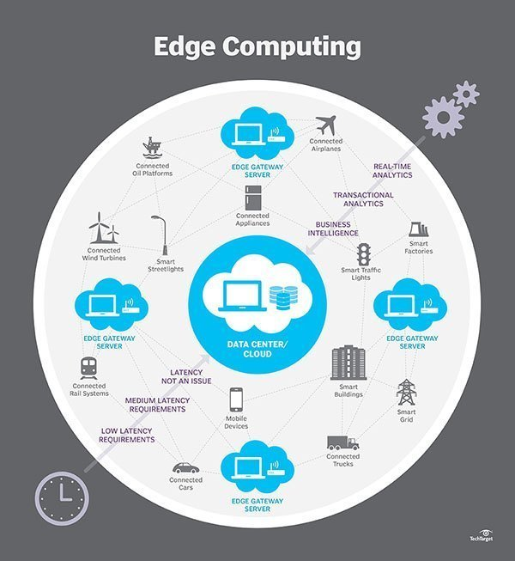
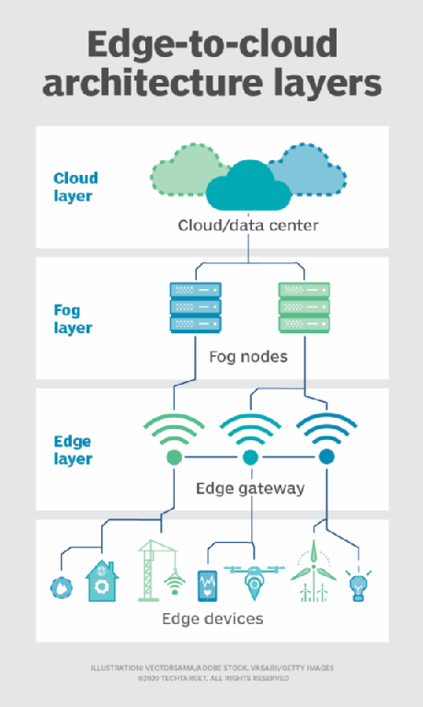
What differentiates edge computing from other computing models ?
Early computing: Centralized applications only running on one isolated computer.
Personal computing: Decentralized applications running locally.
Cloud computing: Centralized applications running in data centers.
Edge computing: Centralized applications running close to users, either on the device itself or on the network EDGE .
An Example of edge computing
Consider a building secured with dozens of high-definition IoT video cameras. These are "dumb" cameras that simply output a raw video signal and continuously stream that signal to a cloud server. On the cloud server, the video output from all the cameras is put through a motion-detection application to ensure that only clips featuring activity are saved to the server’s database. This means there is a constant and significant strain on the building’s Internet infrastructure, as significant bandwidth gets consumed by the high volume of video footage being transferred. Additionally, there is very heavy load on the cloud server that has to process the video footage from all the cameras simultaneously.
Now imagine that the motion sensor computation is moved to the network edge. What if each camera used its own internal computer to run the motion-detecting application and then sent footage to the cloud server as needed? This would result in a significant reduction in bandwidth use, because much of the camera footage will never have to travel to the cloud server.
Additionally, the cloud server would now only be responsible for storing the important footage, meaning that the server could communicate with a higher number of cameras without getting overloaded. This is what edge computing looks like.

Why is Edge Computing Important?
Edge computing is important because it creates new and improved ways for industrial and enterprise-level businesses to maximize operational efficiency, improve performance and safety, automate all core business processes, and ensure “always on” availability. It is a leading method to achieve the digital transformation.
- Powers the next industrial revolution, transforming manufacturing and services.
- Optimizes data capture and analysis at the edge to create actionable business intelligence.
- Creates a flexible, scalable, secure, and more automated technology, systems, and core business process environment.
- Promotes an agile business ecosystem that is more efficient, performs faster, saves costs, and is easier to manage and maintain.

APPLICATIONS

Transportation
Autonomous vehicles require and produce anywhere from 5 TB to 20 TB per day, gathering information about location, speed, vehicle condition, road conditions, traffic conditions and other vehicles. And the data must be aggregated and analyzed in real time, while the vehicle is in motion. This requires significant on-board computing -- each autonomous vehicle becomes an "edge." In addition, the data can help authorities and businesses manage vehicle fleets based on actual conditions on the ground.

2. Remote monitoring of assets in the oil and gas industry
Oil and gas failures can be disastrous. Their assets therefore need to be carefully monitored.
However, oil and gas plants are often in remote locations. Edge computing enables real-time analytics with processing much closer to the asset, meaning there is less reliance on good quality connectivity to a centralised cloud.

3. Smart grid
Edge computing will be a core technology in more widespread adoption of smart grids and can help allow enterprises to better manage their energy consumption.
Sensors and IoT devices connected to an edge platform in factories, plants and offices are being used to monitor energy use and analyse their consumption in real-time by which enterprises and energy companies can strike new deals, for example where high-powered machinery is run during off-peak times for electricity demand. This can increase the amount of green energy (like wind power and solar power) an enterprise consumes.

4. Predictive maintenance
Manufacturers want to be able to analyse and detect changes in their production lines before a failure occurs.
Edge computing helps by bringing the processing and storage of data closer to the equipment. This enables IoT sensors to monitor machine health with low latencies and perform analytics in real-time.

5. In-hospital patient monitoring
Healthcare contains several edge opportunities. Currently, monitoring devices (e.g. glucose monitors, health tools and other sensors) are either not connected, or where they are, large amounts of unprocessed data from devices would need to be stored on a 3rd party cloud. This presents security concerns for healthcare providers.
An edge on the hospital site could process data locally to maintain data privacy. Edge also enables right-time notifications to practitioners of unusual patient trends or behaviours (through analytics/AI), and creation of 360-degree view patient dashboards for full visibility.

6. Virtualised radio networks and 5G (vRAN)
Operators are increasingly looking to virtualise parts of their mobile networks (vRAN). This has both cost and flexibility benefits. The new virtualised RAN hardware needs to do complex processing with a low latency. Operators will therefore need edge servers to support virtualising their RAN close to the cell tower.

7. Cloud gaming
Cloud gaming, a new kind of gaming which streams a live feed of the game directly to devices, (the game itself is processed and hosted in data centres) is highly dependent on latency.
Cloud gaming companies are looking to build edge servers as close to gamers as possible in order to reduce latency and provide a fully responsive and immersive gaming experience.
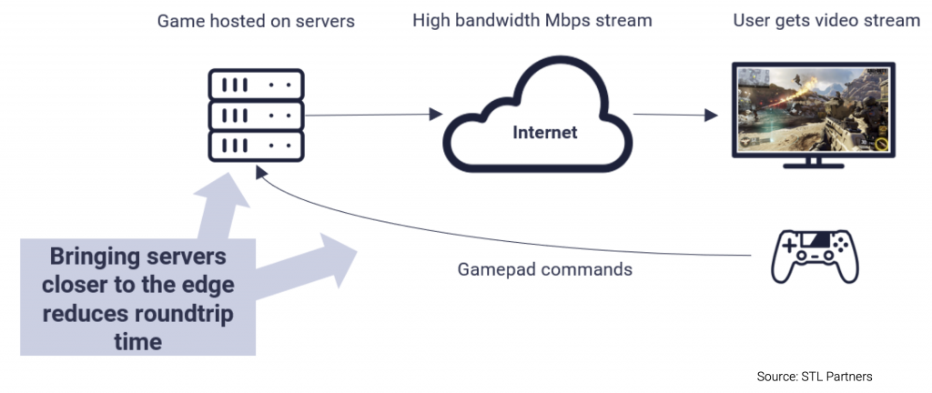

8. Content delivery
By caching content – e.g. music, video stream, web pages – at the edge, improvements to content deliver can be greatly improved. Latency can be reduced significantly. Content providers are looking to distribute CDNs(Content Delivery Networks) customisation on the network depending on user traffic demands.

9. Traffic management
Edge computing can enable more effective city traffic management. Examples of this include optimising bus frequency given fluctuations in demand, managing the opening and closing of extra lanes, and, in future, managing autonomous car flows.
With edge computing, there is no need to transport large volumes of traffic data to the centralised cloud, thus reducing the cost of bandwidth and latency.

What are other possible use cases for edge computing?
Edge computing can be incorporated into a wide variety of applications, products, and services. A few possibilities include:
- Security system monitoring: As described above.
- IoT devices: Smart devices that connect to the Internet can benefit from running code on the device itself, rather than in the cloud, for more efficient user interactions.
- Self-driving cars: Autonomous vehicles need to react in real time, without waiting for instructions from a server.
- More efficient caching: By running code on a CDN edge network, an application can customize how content is cached to more efficiently serve content to users.
- Medical monitoring devices: It is crucial for medical devices to respond in real time without waiting to hear from a cloud server.
- Video conferencing: Interactive live video takes quite a bit of bandwidth, so moving backend processes closer to the source of the video can decrease lag and latency.
What are the benefits of edge computing?

Cost savings- As seen in the example above, edge computing helps minimize bandwidth use and server resources. Bandwidth and cloud resources are finite and cost money. With every household and office becoming equipped with smart cameras, printers, thermostats, and even toasters, Statistician predicts that by 2025 there will be over 75 billion IoT devices installed worldwide. In order to support all those devices, significant amounts of computation will have to be moved to the edge.
2.Performance
Another significant benefit of moving processes to the edge is to reduce latency. Every time a device needs to communicate with a distant server somewhere, that creates a delay. For example, two coworkers in the same office chatting over an IM platform might experience a sizable delay because each message has to be routed out of the building, communicate with a server somewhere across the globe, and be brought back before it appears on the recipient’s screen. If that process is brought to the edge, and the company’s internal router is in charge of transferring intra-office chats, that noticeable delay would not exist.
3.New functionality
In addition, edge computing can provide new functionality that wasn’t previously available. For example, a company can use edge computing to process and analyze their data at the edge, which makes it possible to do so in real time.

Examples of edge computing companies
Global technology players joined the edge computing trend a long time ago. There are already many services that can be used by enterprises to implement edge computing in their data storage. Lets take a look at edge computing use and projects that are being implemented by big organizations.

Siemens
The company launched the Industrial Edge solution, the platform where manufacturers can analyze their machine’s data and its workflow instantly. The non-essential information is transferred to the cloud, which reduces latency on the local network.
Crucial bits are stored at the edge of the network – locally, on the hardware. If there’s an issue with an Internet connection, industrial companies still can keep track of their productivity, detect technical issues, and prevent downtimes.

Saguna
It’s an edge computing provider that offers an infrastructure for edge computing implementation. The company created Open-RAN, the set of tools that help build, deploy, and secure edge computing stores. The tools allow companies to set up low-latency data transfers and secure sensitive information.

ClearBlade
ClearBlade uses the Internet of Things and edge computing to allow enterprises to set up edge computing across multiple devices. If a business has a ready IoT edge device, developers can transfer it to edge storage by using Clear Blade’s development and security tools.

Cisco
Cisco offers a set of communication tools for implementing edge computing, compatible with 4G and 5G connectivity. Businesses can connect their services to the Cisco Network Service Orchestrator to store data, collected by their software, on the edge of the local network and Cisco’s data centers.

IBM
IBM’s IoT platforms and Artificial Intelligence tools support edge computing as one of many possible computing options. Right now, the company’s research is focused on building networking technology that connects multiple edge networks with no WiFi connection

Dell
Dell has been actively investing in the Internet of Things ever since the opening of an IoT division in 2017. The company now adapts edge computing to store data from its IoT edge devices. Dell developed a custom set of specialized instruments: Edge Gateways, PowerEdge C-Series servers, and others.

Amazon
Amazon has already proven to be one of the most stable and powerful cloud computing providers. AWS is the best cloud solution on the market right now. It’s only natural that the company takes an interest in edge computing as well. Lambda@Edge, a service developed by Amazon, allows processing data offline without contacting AWS data centers.

Microsoft
Microsoft has the potential to revolutionize edge computing the way Amazon revolutionized the cloud. The company currently holds more than 300 edge patents and invests in developing multiple IoT infrastructure. The most prominent example is their IoT Azure service, a package of tools and modules for implementing edge computing in IoT projects.

REFERENCE LINKS-
https://searchdatacenter.techtarget.com/definition/edge-computing

https://en.wikipedia.org/wiki/Edge_computing

What is Edge Computing: Advantages, Challenges, Use Cases (jelvix.com)

https://www.cloudflare.com/learning/serverless/glossary/what-is-edge-computing/

